FUEL SURCHARGE OPTIONS

The Miscellaneous changes may be updated via the O-F-6 menu.

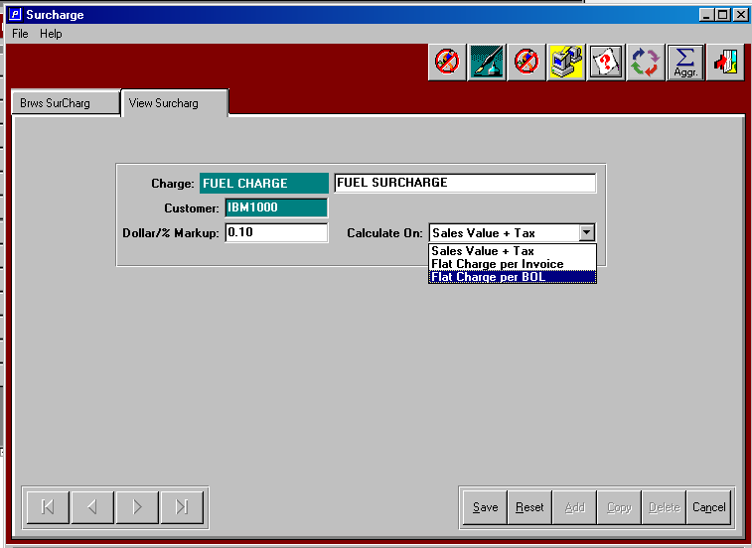

The options above provide the options to automatically invoice for charges such as a fuel charge to reflex the increase in gasoline costs for delivery changes. The charge may apply to specific customers or to all customers and may be applied as a flat charge per invoice or a flat charge per bill of lading delivery or as a percentage of sales and tax value.

If the value is "Sales value + Tax" the valid figure in the amount field is decimal only.
If the value is "Flat dollar per invoice", then the valid figure in the amount field is at least $1.00
If the value is "Flat dollar per BOL", then the valid figure in the amount field is at least $1.00.

The flat charge is always applied to each invoice. If the charge is per BOL, if there are multiple invoices on the bill of lading, the flat surcharge will be applied to the first invoice only. The ability to have a flat charge per BOL or invoice is not related to the billing type in the customer file. This provides the option to either bill a flat surcharge by BOL or Invoice regardless of how the billing method is set in the customer file (i.e. invoice per PO, or invoice per BOL or batch invoices).

FUEL SURCHARGE OPTIONS

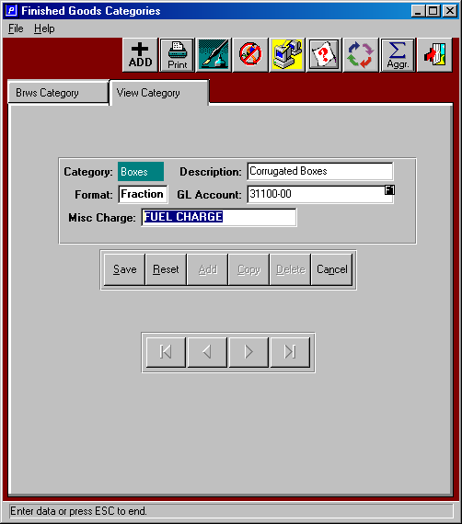

The code FUEL CHARGE as a percentage of sales and tax value must be added to the product categories that will apply the fuel charge. For example the category called BOXES will have FUEL CHARGE under the new MISC CHARGE field. This will trigger a markup percentage times the total dollars + tax for each product category defined as FUEL CHARGE. If customer code exists in the MISC charge Table, then the Fuel Charge will be added to that customer at the percentage defined for that MISC Fuel Charge. If customer code does not exist in the MISC charge Table, then the percentage will be used for all other customers. For categories without the MISC CHARGE such as DIES or RESAL, the markup would not apply. The Description of the Misc Charge Code will print on the Order Invoice form at the bottom of the invoice above the NonTaxable Subtotal. The new Misc Charge will be added to the totals.

